1. **Project Introduction:**

The real estate market is highly dynamic and can be influenced by various factors such as location, property size, amenities, neighborhood, and other related factors. Predicting the accurate price of a property is a crucial task for real estate agents, buyers, and sellers. Machine learning has proven to be a useful tool in predicting property prices. Therefore, this capstone project aims to develop a machine learning model that can accurately predict property prices in a specific location.

1. **Objectives Of the Project:**

1.To collect and clean real estate data from a specific location. 2.How can ordinal and nominal columns be handled separately in property price prediction using the metadata sheet provided to identify which columns are ordinal or nominal? 3.How can scaling, PCA, and fillna() techniques be used in property price prediction to handle missing data and improve the accuracy of the model? 4.To perform exploratory data analysis (EDA) on the collected data to identify key variables that influence property prices. 5.What is the proper encoding technique to be used for ordinal and nominal variables in property price prediction, based on the requirements of the model?

6.To develop a machine learning model that can predict property prices based on the selected variables. 7.To evaluate the performance of the model and compare it with other machine learning algorithms. 8.To present the findings and insights from the project in a clear and concise manner.

1. **Flow Chart Of Operations:**

Methodology: 1.Data Collection: The first step is to collect data on various features of properties in a specific location. This can be achieved by scraping data from real estate websites or collecting data from local real estate agents. 2.Data Cleaning: The collected data will be preprocessed and cleaned to remove missing values, outliers, and other errors. 3.Exploratory Data Analysis (EDA): The cleaned data will be analyzed using EDA techniques to identify important features that influence property prices. 4.Feature Engineering: After identifying the significant features, new features will be created based on domain knowledge or statistical techniques to enhance the predictive power of the model. 5.Model Selection: Various machine learning algorithms, including linear regression, decision trees, and random forests, will be evaluated to determine the best model for predicting property prices. 6.Model Training and Testing: The selected machine learning algorithm will be trained on a subset of the data and tested on the remaining data to evaluate its performance. 7.Model Evaluation: The performance of the model will be evaluated using various metrics such as mean absolute error (MAE) and root mean squared error (RMSE). 8.Model Deployment: The final model will be deployed to predict property prices for new data

1. **Python Codes**

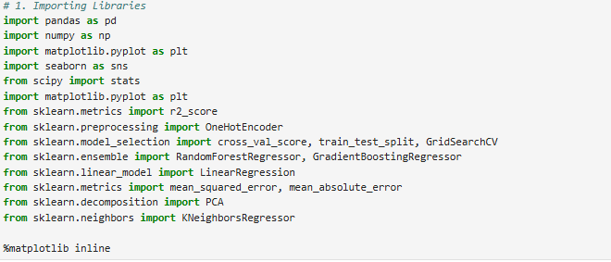

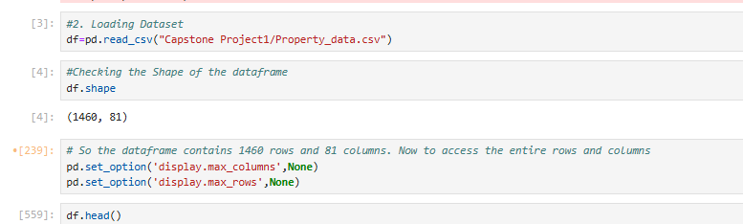

**df.info()**

**df.describe()**

**df.isnull().sum()**

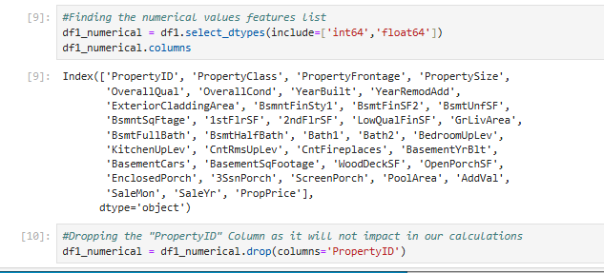

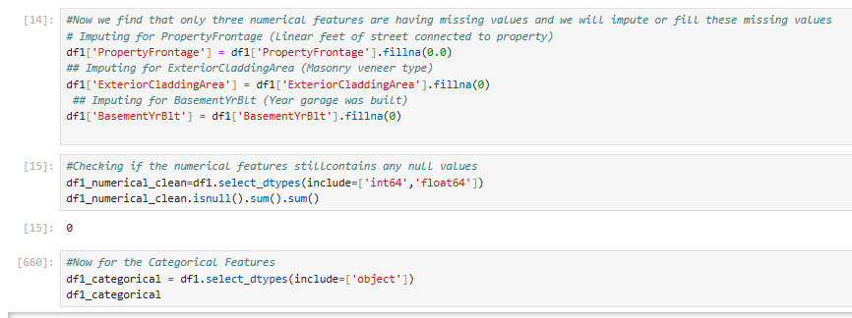

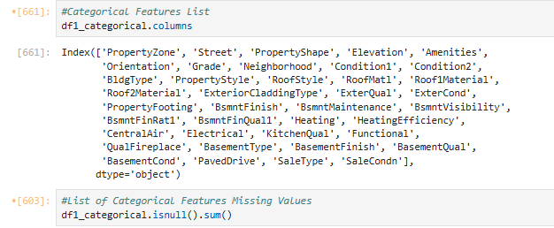



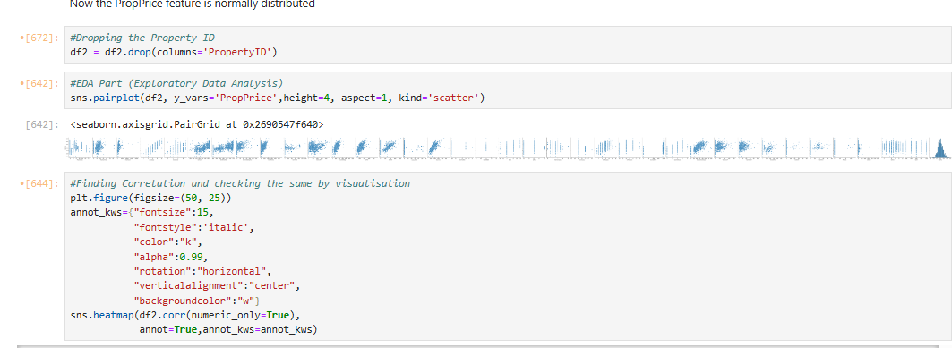

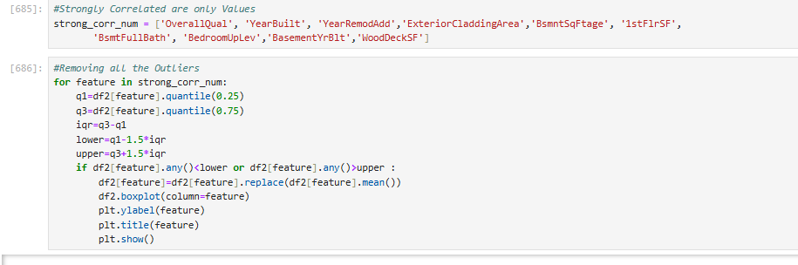

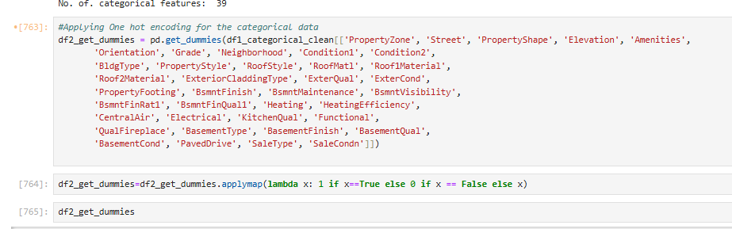

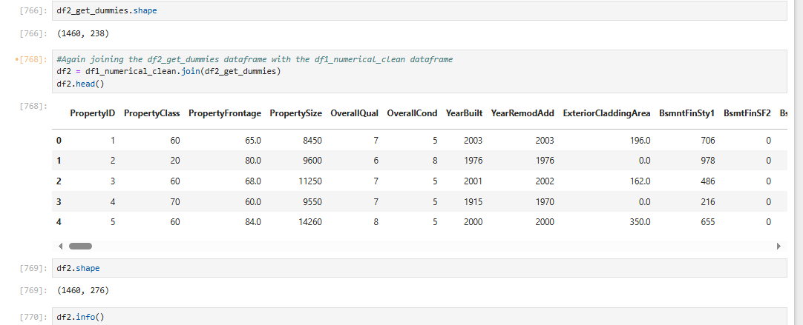

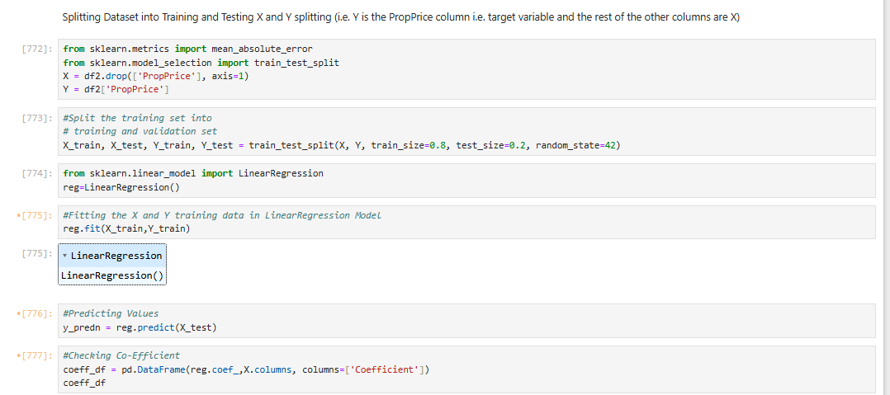

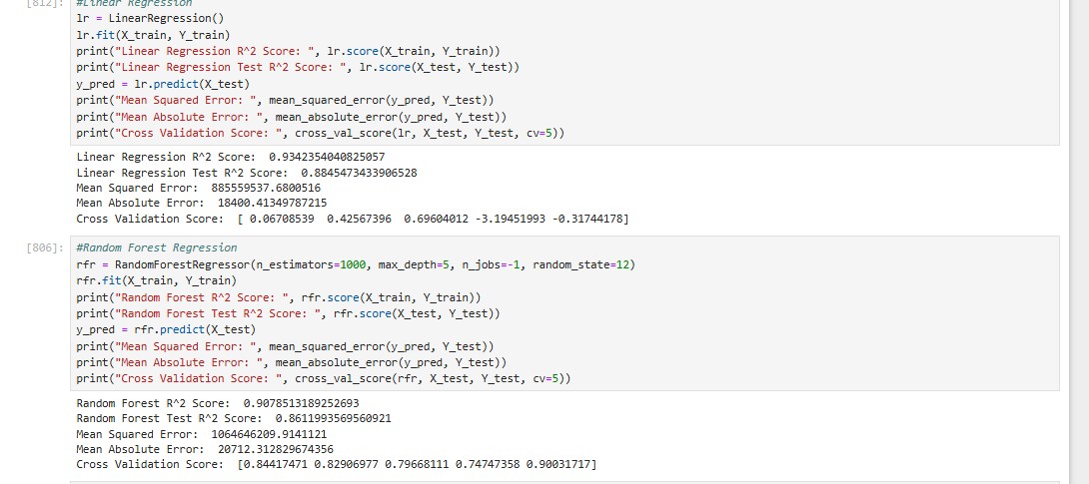

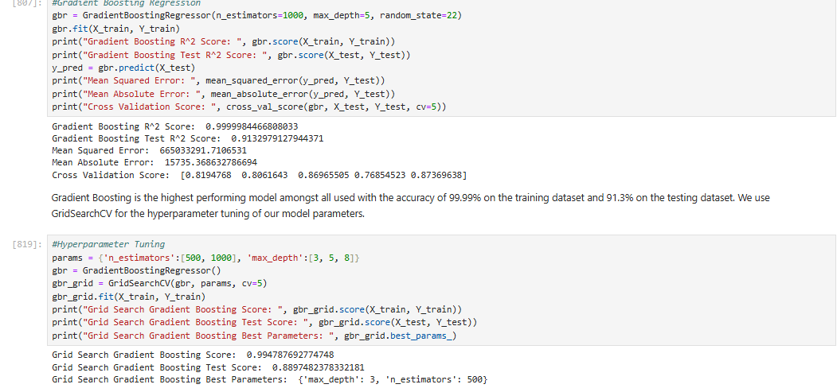

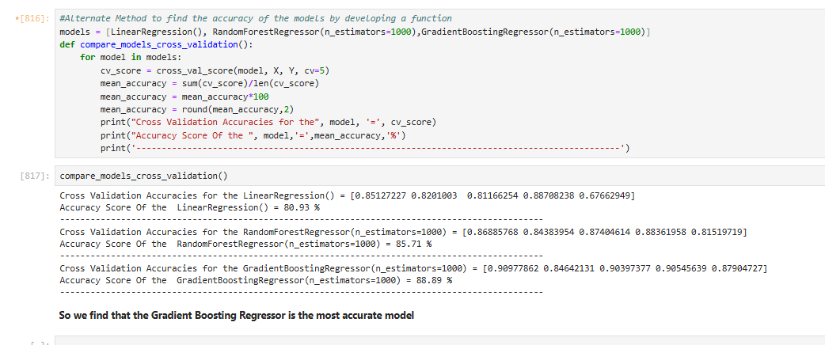

1. **ScreenShots of the Outputs**







1. **Report on EDA (Include Pictures of graphs)**

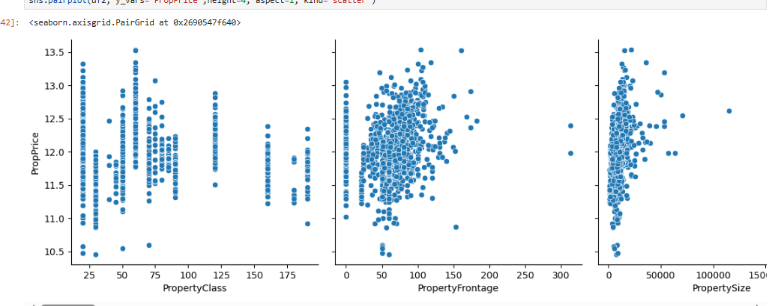

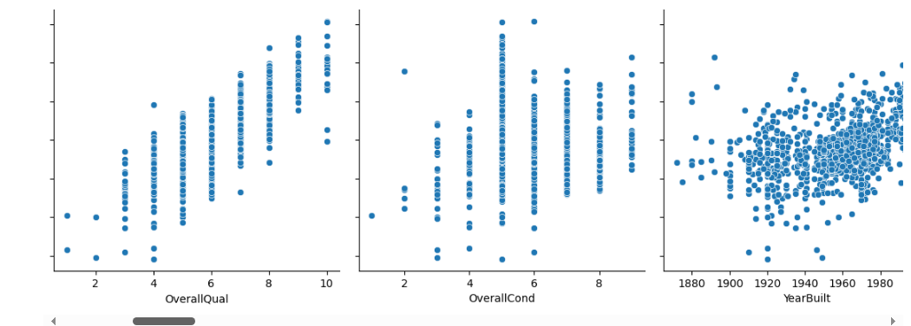

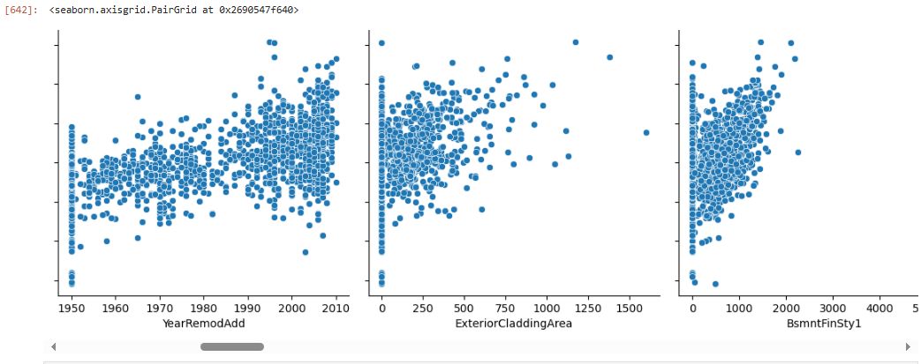

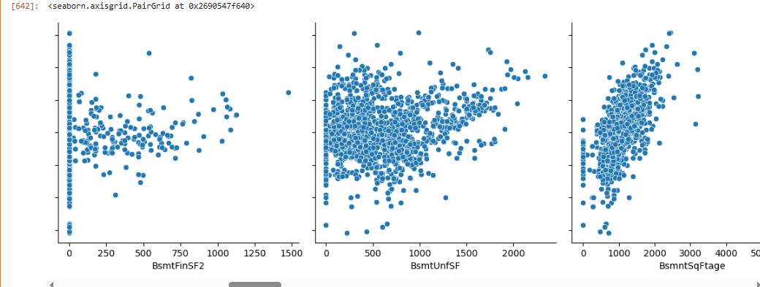

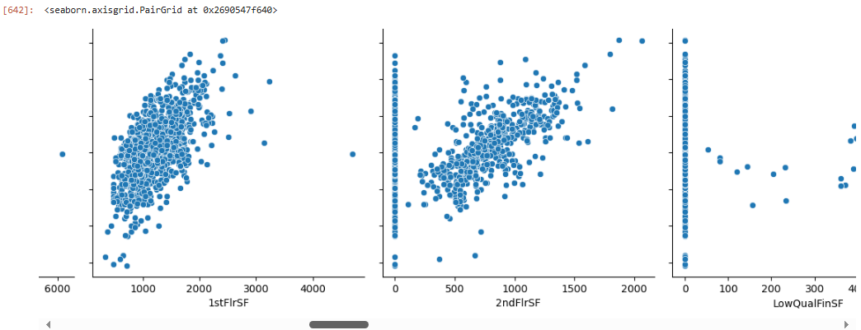

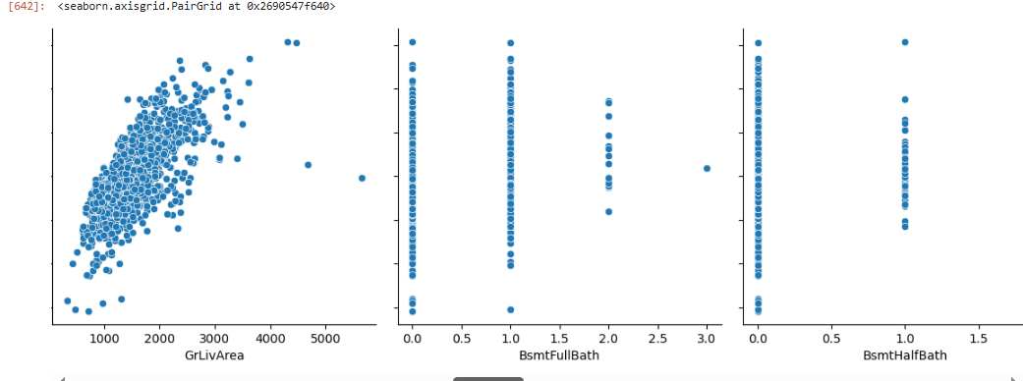

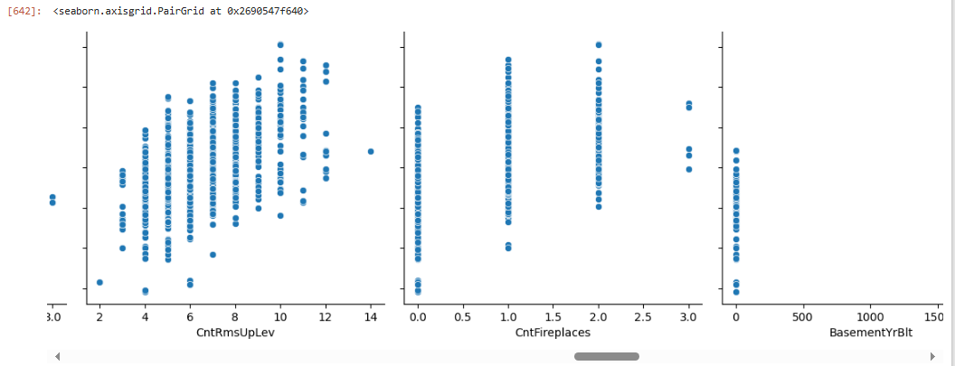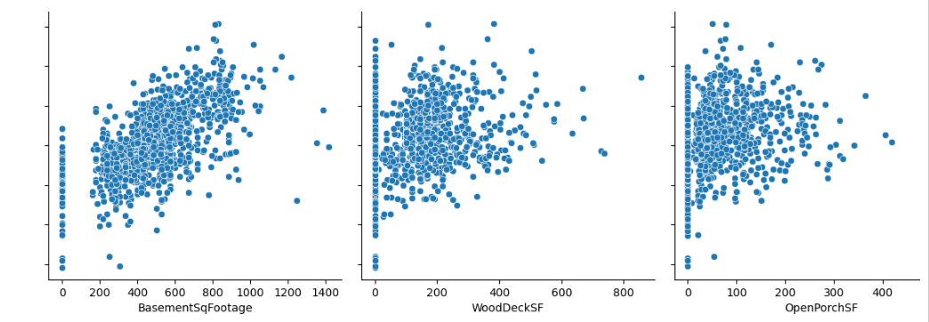

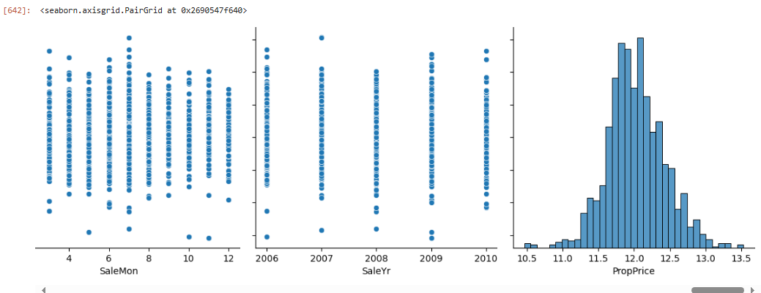

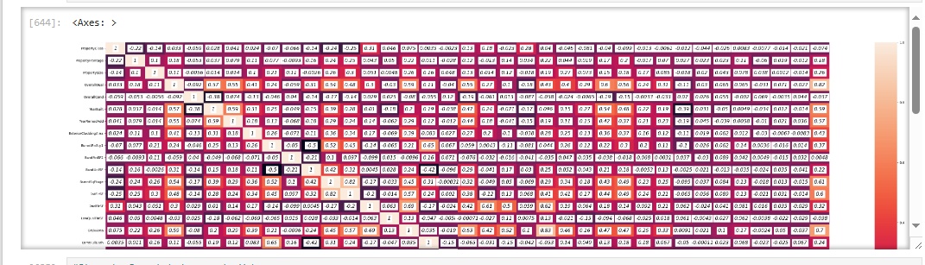

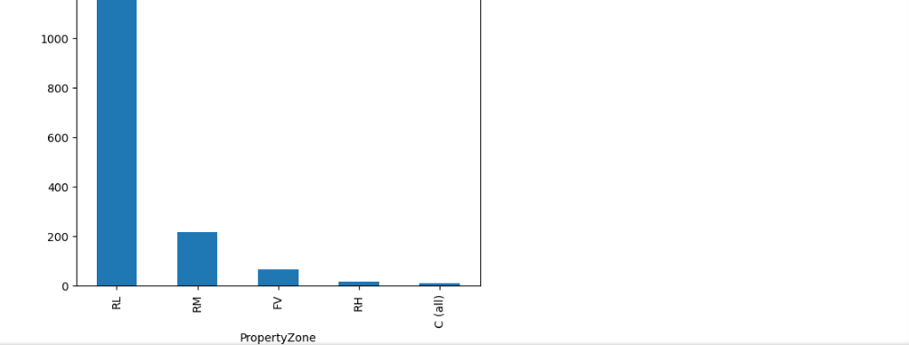

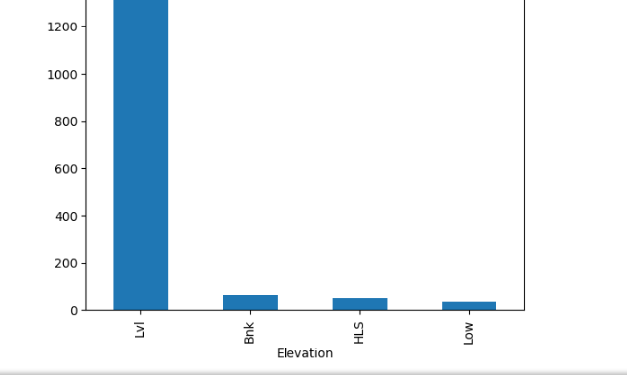

1. **Learning Outcomes**

1.A machine learning model that accurately predicts property prices in a specific location based on selected variables. 2.Insights into the significant features that influence property prices in the specific location. 3.A comprehensive report detailing the methodology, results, and insights from the project.

1. **Conclusion**

This capstone project aims to develop a machine learning model that can predict property prices accurately in a specific location. The project will involve collecting and cleaning data, performing EDA, feature engineering, model selection, training, testing, and evaluation. The final outcome will be a comprehensive report detailing the methodology, results, and insights from the project.

1. **Citations- Books and Websites used**

**Used websites: geeksforgeeks,**

**Youtube Videos: Krishna nayer**